**Inventory Vouchers:**

Inventory Vouchers performs the same function in the inventory system as accounting voucher do. They are the means by which you enter transactions relating to the Inventory. The vouchers record transactions relating to the issue and receipt of stock, the transfer of stock between good owns, and physical stock adjustments. The following inventory vouchers are available:

* **Purchase Order (alt+f4)**
* **Stock Journal (alt+f7)**
* **Sales Order (alt+f5)**
* **Delivery Note (alt+f8)**
* **Rejections Out (alt+f6)**
* **Receipt Note (alt+f9)**
* **Rejection In (ctrl+f6)**
* **Physical Stock (alt+f10).**

**Purchase order (alt+f4):** Purchase order has to be made in the books of the company to assist them in checking whether the goods have been received or not. The purchase order number can be used as a reference. For example, the company wishes to place an order with the supplier for some goods.

**Sales Order (alt+f5):** When the order is received from a customer for goods to be supplied, the Items, quantities, date of delivery, etc., details are given with Sales Order Number. Laterwhen these goods are delivered, this Sales Order is tracked for the order Detailseither in the delivery note or in the sales invoice.

**Rejections Out (alt+f6):** A rejection out entry is passed to record the rejected goods. This is a pure inventoryvoucher.

**Rejections In (ctrl+f6)**: A rejection in entry is passed to record the rejected goods. The Rejection In entry is a pure inventory voucher. For example: a costumer has rejected goods that was sold earlier. ) Description Records rejected stock details received from customer. Details Recorded Ledger account, Customer name and address, Order details, Stock item, Tracking

**Stock Journal (alt+f7):** To record the consumption of goods there is no need for entries in both sides of the voucher. Such entries can be entered in a stock journal voucher. For example: the company transfers the items of stock from the warehouse to shop.

**Delivery Note (alt+f8)**: Goods that are being delivered to a customer in a Delivery Note Voucher. Records delivery of new stock to customers. Details Recorded Reference, Ledger account, Suppliers(if supplementary details are set to yes in f12: Delivery Note Configuration)then, name and address, Order and dispatch details, Name of stock item, Order details, Goods owned, Quantity, Rate(optional),Amount(optional), Narration.

**Receipt Note (alt+f9):** Goods that are received from the supplier are recorded in a Receipt Note (GoodsReceipt Note – GRN) voucher. Records receipt of new stock from supplier. Details Recorded Reference, Ledger account, Suppliers(if supplementary details are set to yes in f12: Delivery Note Configuration)then, name and address, Name of stock item, Order details, Goods owned, Quantity, Rate(optional), Amount(optional),Narration.

**Physical Stock Voucher (alt+f10**): It consider the stock available based on the entry made in a physical stock voucher. For example: on conducting a stock, the company finds a discrepancy between the actual stock and the recorded stock figure.

**Creating inventory voucher:**

**Open tally >> gateway of tally >> inventory vouchers**

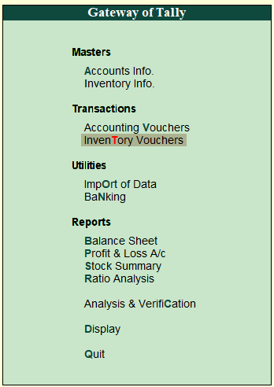

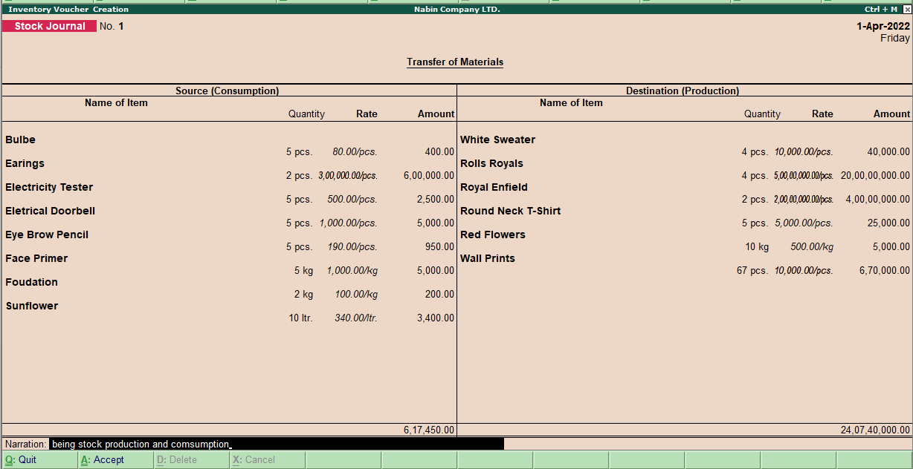

**Cash and bank book of Nabin Company LTD.**

A cash book is a financial journal that contains all cash receipts and disbursements, including bank deposits and withdrawals. Entries in the cash book are then posted into the general ledger.

**Path:** Gateway of Tally>> Display Menu>> Account Books >> Cash/Bank Summary

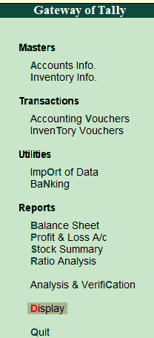 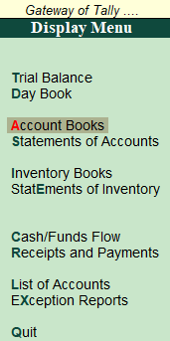 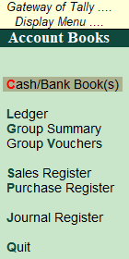

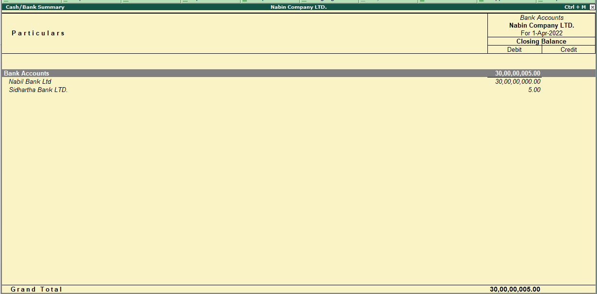**Sales register of April month in Nabin Company LTD.**

The sales register is the book in which we keep a record of all credit transactions connected to the Sale of goods. The Sales Account is the ledger account where all business transactions involving the Sale of goods for money or credit are recorded. The balance of the sales register does not affect the Financial Statement of the business.

**Path:** Gateway of Tally --> Display Menu --> Account Books --> Sales Register

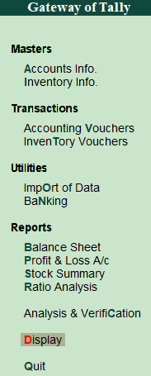 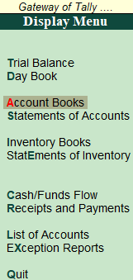 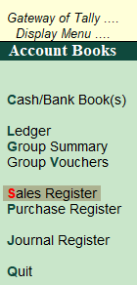

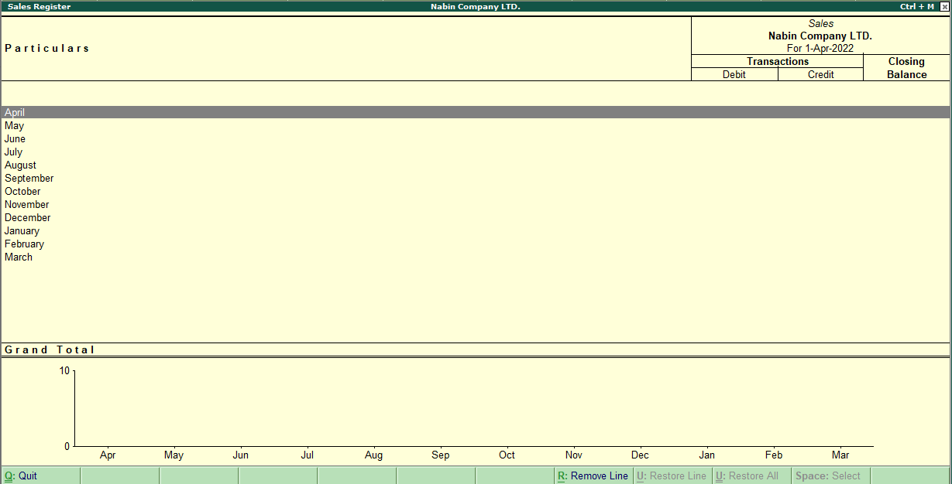

**Statistics of accounts**

**Path:** Gateway of Tally --> Display Menu --> Statements of Accounts--> Statistics

